**Call web APIs:**

To connect to APIs, please open tool that supports these functionalities (for example you

can use Postman, Swagger, etc)

In the instruction file I used Swagger (<https://localhost:7070/swagger/index.html>)

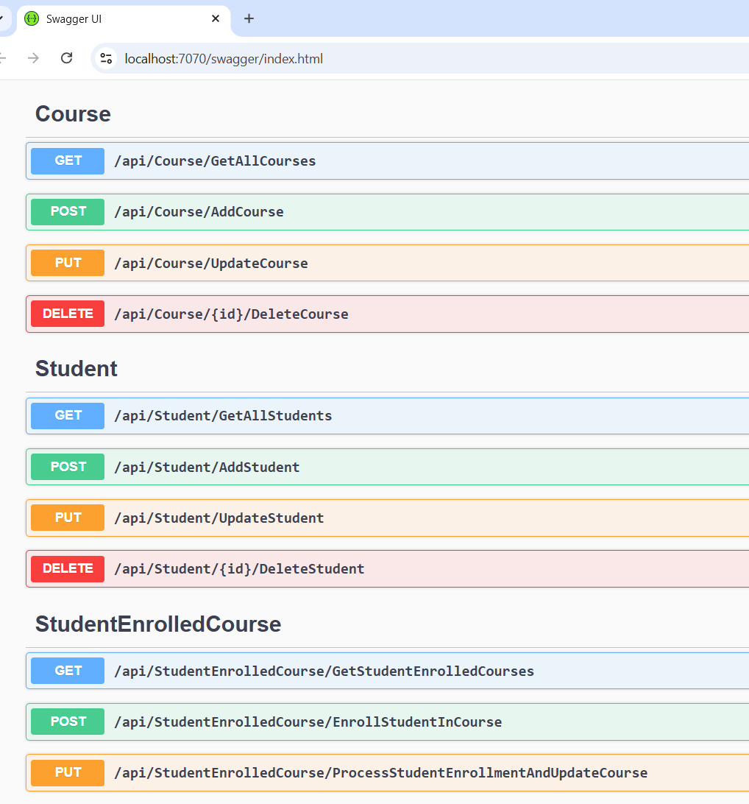

**Let's test the API:**

First open Microsoft Visual Studio Community 2022 (64-bit) and run the project.

Application URL: https://localhost:7070

1. **Courses: CRUD operations**
2. **GET /api/Course/GetAllCourses**
3. **POST** /api/Course/AddCourse
4. **PUT /api/Course/UpdateCourse**
5. **DELETE** /api/Course/{id}/DeleteCourse
6. **Students CRUD operations**
7. **GET /api/Student/GetAllCourses:**
8. **POST** /api/ **Student** /AddCourse
9. **PUT /api/ Student /UpdateCourse**
10. **DELETE** /api/ **Student** /{id}/DeleteCourse
11. **StudentEnrolledCourse**
12. **GET /api/StudentEnrolledCourse/GetStudentEnrolledCourses**
13. **POST** /api/StudentEnrolledCourse/EnrollStudentInCourse
14. **PUT /api/StudentEnrolledCourse/EnrollStudentInCourse**
15. **Courses: CRUD operations**
16. **GET /api/Course/GetAllCourses**

**Just execute the API without params:**

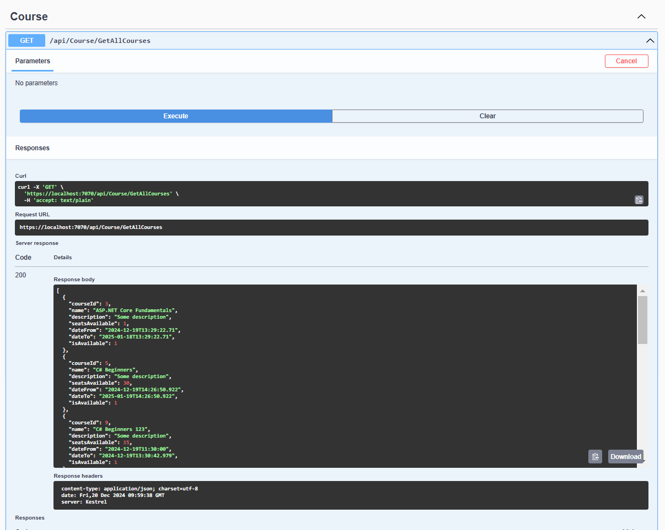

1. **POST** /api/Course/AddCourse

**Params:**

{

"name": "C# Beginners ",

"description": "Some description",

"seatsAvailable": 15,

"dateFrom": "2024-12-19T14:38:42.979Z",

"dateTo": "2024-12-19T14:38:42.979Z"

}

**Example with** validation errors appears, because the dateFrom must be < dateTo:

{

"name": "C# Beginners ",

"description": "Some description",

"seatsAvailable": 15,

"dateFrom": "2024-12-19T14:38:42.979Z",

"dateTo": "2024-12-19T14:38:42.979Z"

}

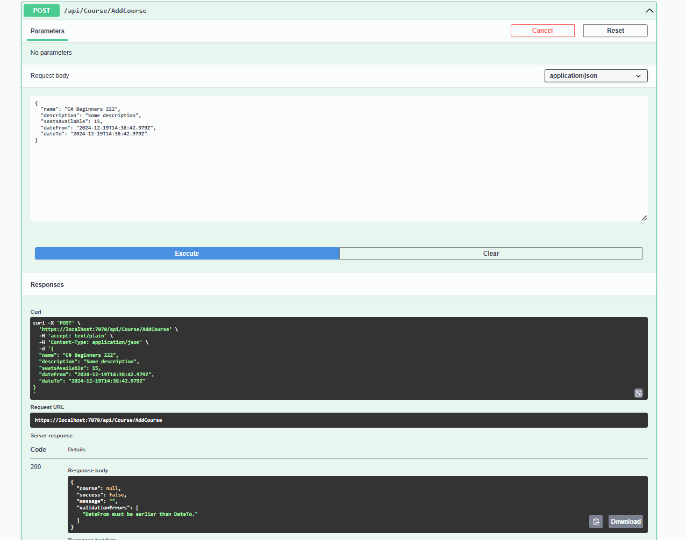

Example with working one:

{

"name": "C# Beginners 1",

"description": "Some description",

"seatsAvailable": 15,

"dateFrom": "2024-12-19T14:38:42.979Z",

"dateTo": "2025-01-20T14:38:42.979Z"

}

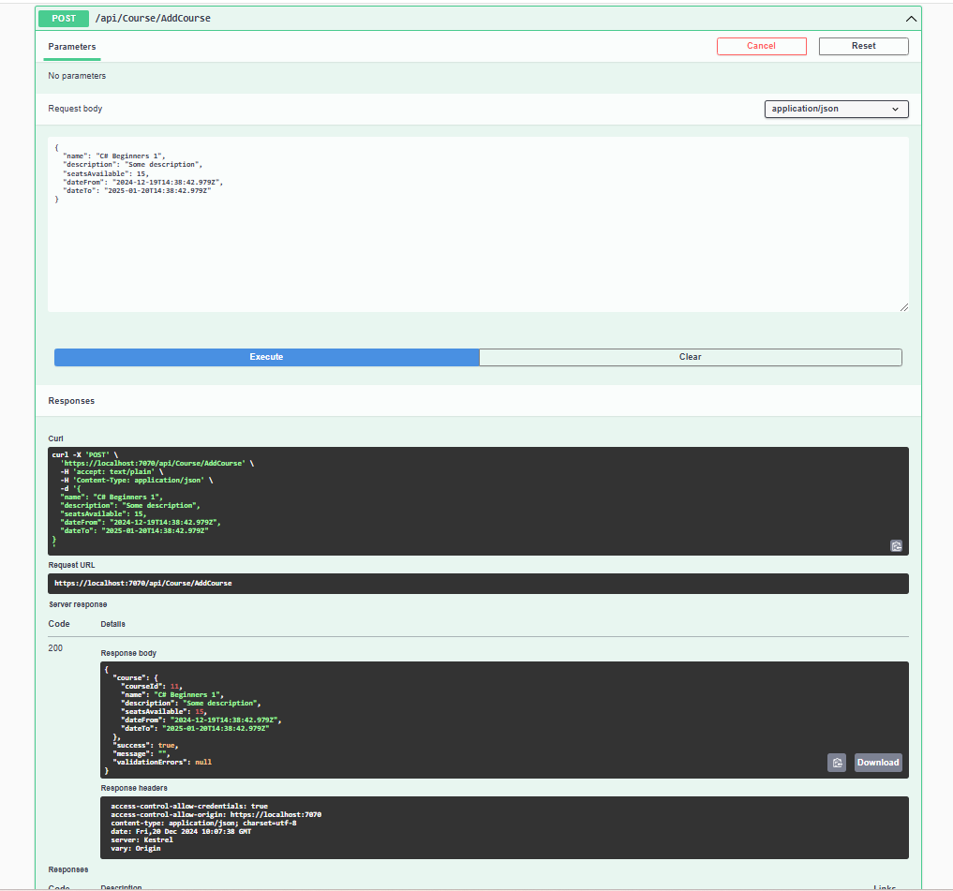

1. **PUT /api/Course/UpdateCourse**

**Params:**

{

"courseId": 0,

"name": "string",

"description": "string",

"seatsAvailable": 0,

"dateFrom": "2024-12-20T10:08:52.592Z",

"dateTo": "2024-12-20T10:08:52.592Z",

"isAvailable": 0

}

Example:

{

"courseId": 11,

"name": "C# Beginners 1",

"description": "Some description",

"seatsAvailable": 15,

"dateFrom": "2024-12-19T14:38:42.979Z",

"dateTo": "2025-01-20T14:38:42.979Z",

"isAvailable": 1

}

1. **DELETE** /api/Course/{id}/DeleteCourse

**Params:**

{

"courseId": 0

}

Example:

{

"courseId": 1

}

1. **Students CRUD operations**
2. **GET /api/Student/GetAllStudents**

**Params: No params**

**Example:**

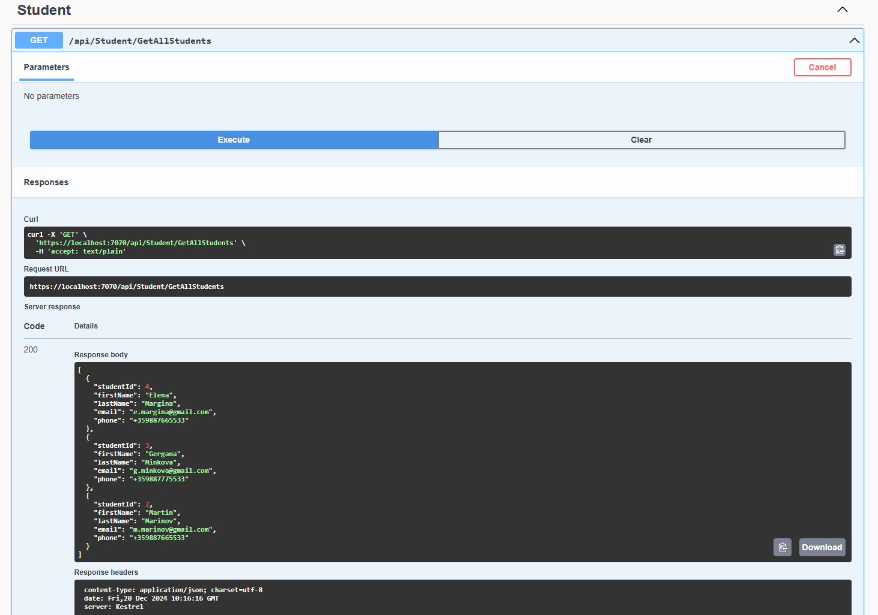

1. **POST** /api/ **Student** /AddStudent

**Params:**

{

"firstName": "string",

"lastName": "string",

"email": "string",

"phone": "string"

}

**Example:**

{

"firstName": "Elena",

"lastName": "Marinova",

"email": "e.margina@gmail.com",

"phone": "+359887665533"

}

1. **PUT /api/ Student /UpdateStudent**

**Params:**

{

"studentId": 0,

"firstName": "string",

"lastName": "string",

"email": "string",

"phone": "string"

}

**Example:**

{

"studentId": 1,

"firstName": "Georgy",

"lastName": "Minchov",

"email": "g.petrov@gmail.com",

"phone": "+359887665544"

}

1. **DELETE** /api/ **Student** /{id}/DeleteStudent

**Params:**

**{**

**"studentId": 0**

**}**

**Example:**

**{**

**"studentId": 2**

**}**

1. **StudentEnrolledCourse**
2. **GET /api/StudentEnrolledCourse/GetStudentEnrolledCourses**

**Params: StudentID**

**Example: 2  
Response body**

**Download**

**{**

**"studentId": 1,**

**"fullName": "Georgy Petrov",**

**"email": "g.petrov@gmail.com",**

**"course": [**

**{**

**"enrollmentId": 1,**

**"enrollmentDate": "2024-12-20T14:28:56.5166667",**

**"progress": 50,**

**"status": "InProgress",**

**"courseId": 3,**

**"name": "ASP.NET Core Fundamentals",**

**"description": "Some description",**

**"seatsAvailable": 1,**

**"dateFrom": "2024-12-20T14:28:56.4966667",**

**"dateTo": "2025-01-19T14:28:56.4966667",**

**"duration": 30,**

**"isAvailable": "Yes"**

**},**

**{**

**"enrollmentId": 4,**

**"enrollmentDate": "2024-12-20T14:28:56.5166667",**

**"progress": 10,**

**"status": "InProgress",**

**"courseId": 4,**

**"name": "ASP.NET Core Fundamentals 2",**

**"description": "Some description",**

**"seatsAvailable": 1,**

**"dateFrom": "2024-12-20T14:28:56.4966667",**

**"dateTo": "2025-01-29T14:28:56.4966667",**

**"duration": 40,**

**"isAvailable": "Yes"**

**}**

**]**

**}**

1. **POST** /api/StudentEnrolledCourse/EnrollStudentInCourse

**Params:**

{

"studentId": 3,

"courseId": 1

}

**Example:**

{

"studentId": 3,

"courseId": 1

}

**Response body**

**Download**

**{**

**"createStudentEnrolledCourse": {**

**"enrollmentId": 5,**

**"studentId": 3,**

**"fullName": "",**

**"email": "",**

**"enrollmentDate": "2024-12-20T10:29:27.845915Z",**

**"progress": 0,**

**"status": "enrolled",**

**"course": {**

**"courseId": 1,**

**"name": "C# Fundamentals",**

**"description": "Some description",**

**"seatsAvailable": 1,**

**"dateFrom": "2024-12-19T13:29:22.71",**

**"dateTo": "2025-01-18T13:29:22.71",**

**"duration": 30,**

**"isAvailable": "Yes"**

**}**

**},**

**"success": true,**

**"message": "",**

**"validationErrors": null**

**}**

1. **PUT /api/StudentEnrolledCourse/EnrollStudentInCourse**

**Params:**

{

"studentId": 0,

"courseId": 0,

"progress": 0,

"status": "string"

}

Here the options for the status are:

1. - Enrolled, // Student is actively enrolled

1 - InProgress, // Student has started the course

2 - Completed, // Student has completed the course

3 - Cancelled // Enrollment was cancelled

**Example:**

{

"studentId": 2,

"courseId": 1,

"progress": 10,

"status": "InProgress"

}

**Response body**

**Download**

**{**

**"success": true,**

**"message": "",**

**"validationErrors": null**

**}**